

Writing Your Dissertation in APA Style

Guidelines

Order of Preliminary Pages - (Use Roman numeral)

- Title page (counted as page “I” but not numbered)
- Copyright (if applicable) (not numbered or counted)
- Abstract
- Acknowledgements
- Table of Contents
- List of Tables
- List of Figures

Title Page
- Running head: The running head is an abbreviated title, max 50 characters. It should be flush left in all uppercase letters at the top of the title page and all subsequent pages. The use of a running head is REQUIRED.
- Title: The recommended length for a title is no more than 12 words. The title should be typed in all CAPS, centered between the left and right margins and positioned at the top of the page.
- No abbreviations in the title
- Date should be the diploma date
- Title should be double-spaced

Copyright
- This page is placed after the title page. It does not get numbered, nor does it count as a page number.

Abstract
- Center the word Abstract at the top of the page in uppercase and lowercase letters
- Double-spaced in one single paragraph
- Should not exceed 350 words
- No indentation

Acknowledgments
- Indent & double-space paragraphs
- If you have a Dedication page, it precedes the acknowledgments page (same format)

Table of Contents
- Include all headings and subheadings, as they appear in the text, up to and including Level 2.
- The words TABLE OF CONTENTS should be in all caps and centered at the top of the page.

List of Tables

- Center title in CAPS
- Double-space between Table numbers
- Number tables in Arabic numerals

List of Figures
- Center title in CAPS
- Number figures in Arabic numerals

Additional Formatting Guidelines

Margins
- Left margin – 1” or 1 ½”. Although one-inch margins are required by APA, students can elect to use 1½” if that appearance is desired for bounded, hard copies of the dissertation.
- All other margins – 1”

Font
- Times New Roman, 12pt is the recommended font per the APA publication manual. Regardless of the font chosen, be consistent in using the same font throughout

Line Spacing
- Double-space the entire dissertation with these exceptions (single-spaced)
- Table column headers can be single or double-spaced (whichever one is chosen, be consistent)

Page Numbering
- After arranging in the correct order, number pages consecutively beginning with the title page.
- Page numbering should be placed in the upper right-hand corner.
- Beginning with page 1 of Chapter I, Arabic numerals are used and are continuous through the last page, including all appendices.

Headings
Levels of headings in APA
- Centered, Boldface, Uppercase and Lowercase Heading
- Flush Left, Boldface, Uppercase and Lowercase Heading
- Flush Left, Bold italic, Uppercase and Lowercase Heading
- Indented, Boldface, Uppercase and Lowercase Heading, Ending with a period.
- Indented, Boldface, Uppercase and Lowercase Heading, Ending with a period.

- Do not label headings with numbers or letters
- If using APA style for headings, use the following Level 1 headings (Introduction, Literature Review, Method, Results, Discussion, and References)
- If using the term “Chapter” as a Level 1 heading, please use the following format (Chapter X: Name of chapter)

Appendices
- Begin each appendix on a separate page
- Center the word Appendix and the identifying capital letter (A, B, etc.) in the order in which it is mentioned.

References
- Center and bold the word References in upper and lowercase text.

Sample Pages
- Title Page
- Copyright
- Abstract
- Acknowledgements
- Table of Contents
- List of Tables
- List of Figures

TITLE (All caps & double-spaced)

A DISSERTATION
SUBMITTED TO THE FACULTY
OF
THE GRADUATE SCHOOL OF APPLIED AND PROFESSIONAL PSYCHOLOGY
OF
RUTGERS,
THE STATE UNIVERSITY OF NEW JERSEY
BY
FULL NAME (same as on diploma)
IN PARTIAL FULFILLMENT OF THE
REQUIREMENTS FOR THE DEGREE
OF
DOCTOR OF PSYCHOLOGY

NEW BRUNSWICK, NEW JERSEY MONTH and YEAR
(diploma date – October, January or May)

APPROVED: ___________________________
Dissertation Chair’s Name
(replace with names under signature line)
___________________________
2nd Committee Member’s Name

DEAN: ___________________________
Dean’s Name

Copyright year by Firstname Lastname
(Diploma year)

(this page does not get numbered, nor does it count as a numbered page)
Abstract

TEXT (double-spaced – no indentation – one long paragraph, maximum 350 words)

Acknowledgements

TEXT (double-spaced – indented)

Table of Contents
(SAMPLE 1 – USE OF CHAPTER HEADINGS)

Abstract ii
Acknowledgements iii
LIST OF TABLES v
LIST OF FIGURES vii
Chapter I: Title of Chapter 1
Level 2 Heading 1
Level 3 Heading (optional) 1
Chapter II: Title of Chapter 3
Level 2 Heading 3
Chapter III: Title of Chapter 4
Level 2 Heading 4
Chapter IV: Title of Chapter 5
Level 2 Heading 5
Chapter V: Title of Chapter 7
Level 2 Heading 7
Appendices 8
References 10

Table of Contents
(SAMPLE 2 - USE OF APA JOURNAL STYLE)

Abstract ii
Acknowledgements iii
LIST OF TABLES iv
LIST OF FIGURES v
INTRODUCTION 1
Level 2 Heading 5
Level 2 Heading 8
REVIEW OF LITERATURE 10
Level 2 Heading 14
Level 2 Heading 16
METHODOLOGY 17
Level 2 Heading 19
Level 2 Heading 21
RESULTS 16
Level 2 Heading 18
Level 2 Heading 21
DISCUSSION 22
Level 2 Heading 24
Level 2 Heading 27
APPENDICES 30
REFERENCES 39

LIST OF TABLES
Table Page #
1. Insert Table Heading 3
2. Insert Table Heading 12

List of FIGURES
Figures Page #
1. Insert Figure Heading 6
2. Insert Figure Heading 17
3. Insert Figure Heading 28

Ensuring Your Dissertation is ADA-compliant

Guidelines

Compliance checkpoints

- Use of Text
- Use of Color
- Use of Shape, Size, and Position
- Heading Styles
- Tables
- Alternative Text
- Links

Use of Text
- Use a sans serif font (APA recommends Arial or Calibri).
- Use a 12 pt font or larger.
- Do not utilize images of text.
- Check for a strong contrast between the font color and the background color.
  - Why: Low contrast can make content hard to read or understand for users with visual impairments, including color blindness.
  - WCAG requires normal text to be at least 4.5:1 and large text (18 pt or 14 pt bold and above) to be at least 3:1.
  - Free contrast checker
  - Hex Value for Black: 000000
  - Hex Value for White: FFFFFF

Use of Color
- Any information conveyed through color must also be paired with text or another visual indicator to ensure clarity.
- Why: Color-only cues can make content hard to read or understand for users with visual impairments, including color blindness.
- Don’t forget to check your contrast levels.
- The chart below is not ADA-compliant because the only way to differentiate the data is by color.
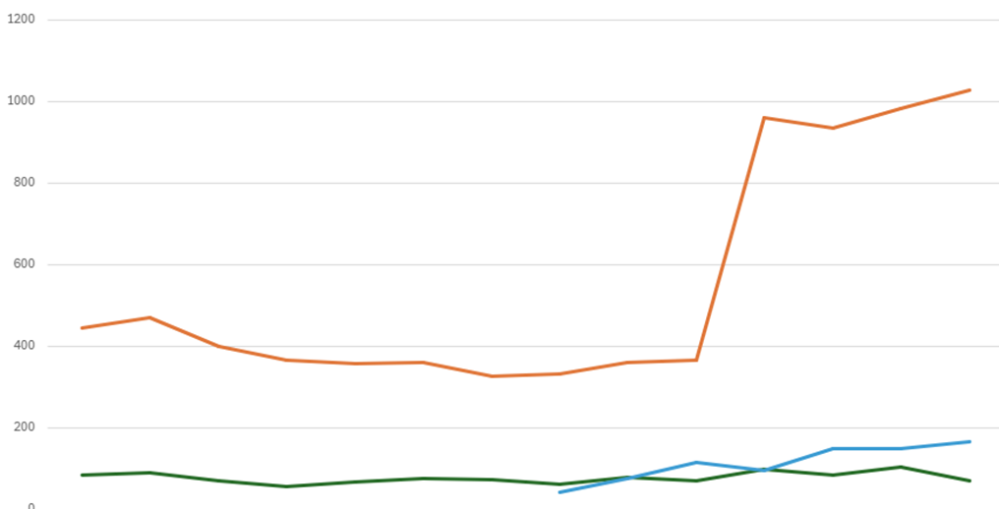

- The chart below is ADA-compliant because the data are differentiated by both color and design (i.e., solid lines, dashes, and dots).
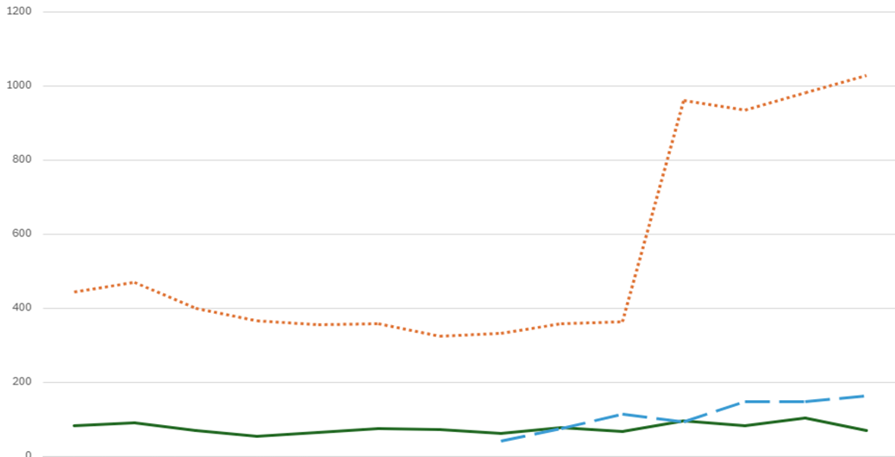

Size, Shape, and Position
- Content must be presented in a way that does not depend on references to shape, size, or their position on the page for understanding.
- Why: Relying on the shape, size, and position can make content hard to read or understand for users with visual impairments.
Non-compliant examples:
- The text in the upper right-hand corner is from…
- The numbers in the square represent…. To contrast, the numbers in the circle are…
- The larger words in the word cloud represent the more frequent responses to the survey.

Heading Styles
- Organize your content using heading styles in a sequential order without skipping levels, to enhance readability.
- Why: Headings provide structure and help screen readers navigate content.
- Use built-in heading styles (e.g., H1, H2) rather than changing font size or making text bold. Ensure your heading styles align with APA formatting requirements.

Tables
- Create simple tables with clear column and row headers for better comprehension.
- Only use tables to organize data, not for formatting purposes.
- Why: Layout tables confuse screen readers and mobile users.
- Creating a table in another program (e.g., Excel, SPSS, etc.) and pasting it into a Word Doc will cause screen readers to read it as an image.
- Remember to check your font size and contrast.
- Steps to Creating an Accessible Table in Word

Alternative Text (Alt text)
- Always provide descriptive alternative text (alt text) for images, graphs, and charts to make them accessible to all users.
- Why: Alt text conveys the purpose of an image to users who cannot see it.

- Tips for writing Alt Text:
  - Focus on the purpose of the image
    - Describe its meaning in the context of the document
  - Be brief, specific, and concise
    - One or two brief, specific sentences
  - Include key information and summarize data
    - State the main takeaway
  - Avoid Redundancy
    - Don’t repeat nearby text, or write “picture of…” or “graphic showing…”

- Example: Red and Black “Block R” logo for the Graduate School of Applied and Professional Psychology at Rutgers – New Brunswick.

Links
- Use descriptive text for external and internal links that clearly convey the purpose of the link from the text alone.
- Why: Screen readers often browse links out of context.
- Avoid “click here” or “read more” as link text.
- “Chapter One” or “Download Table 3” are examples of ADA-compliant links.

